Схема базы данных TCP-H

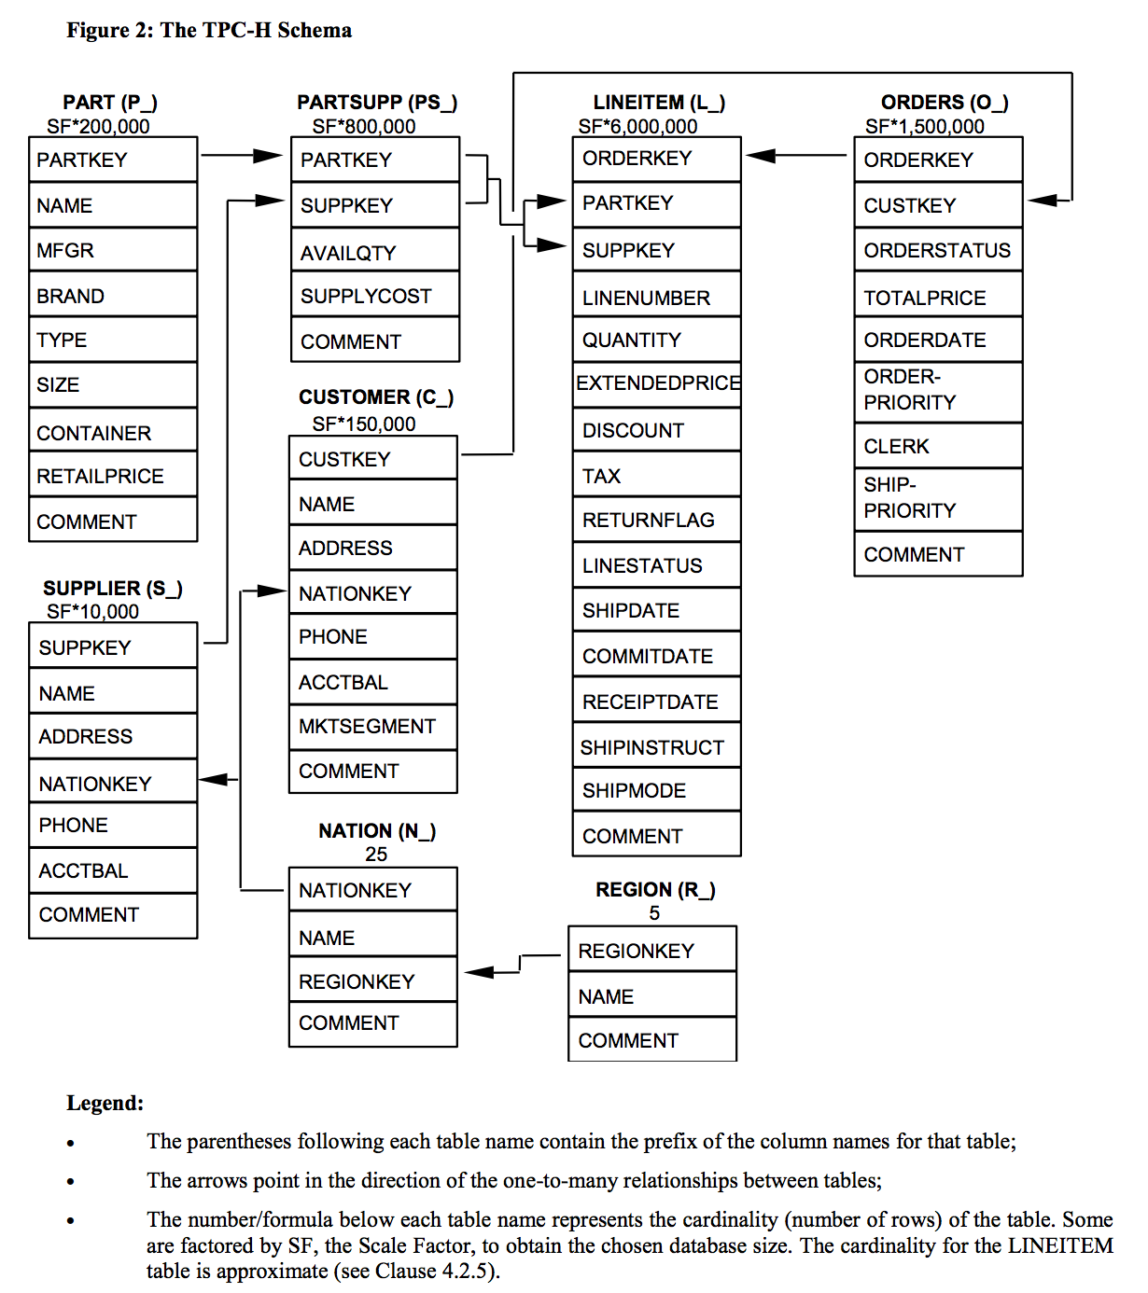

В общедоступных источниках был найден следующий запрос: This query identifies suppliers in the United Kingdom having parts like “metallic%” that may be candidates for a promotional offer.
SELECT
s_name,
s_address
FROM
supplier,
nation
WHERE
s_suppkey IN (
select ps_suppkey
from partsupp
where ps_partkey IN (
select p_partkey
from part
where p_name LIKE 'metallic%'
)
AND ps_availqty > (
select 0.5 * SUM(l_quantity)
from lineitem
where l_partkey = ps_partkey
AND l_suppkey = ps_suppkey
and l_shipdate >= date '1995-01-01'
and l_shipdate < date '1995-01-01' + interval '1 year'
)
)
and s_nationkey = n_nationkey
AND n_name = 'UNITED KINGDOM'
ORDER BY
s_name

- Смотрим сколько времени будет выполнятся запрос с помощью EXPLAIN ANALYZE

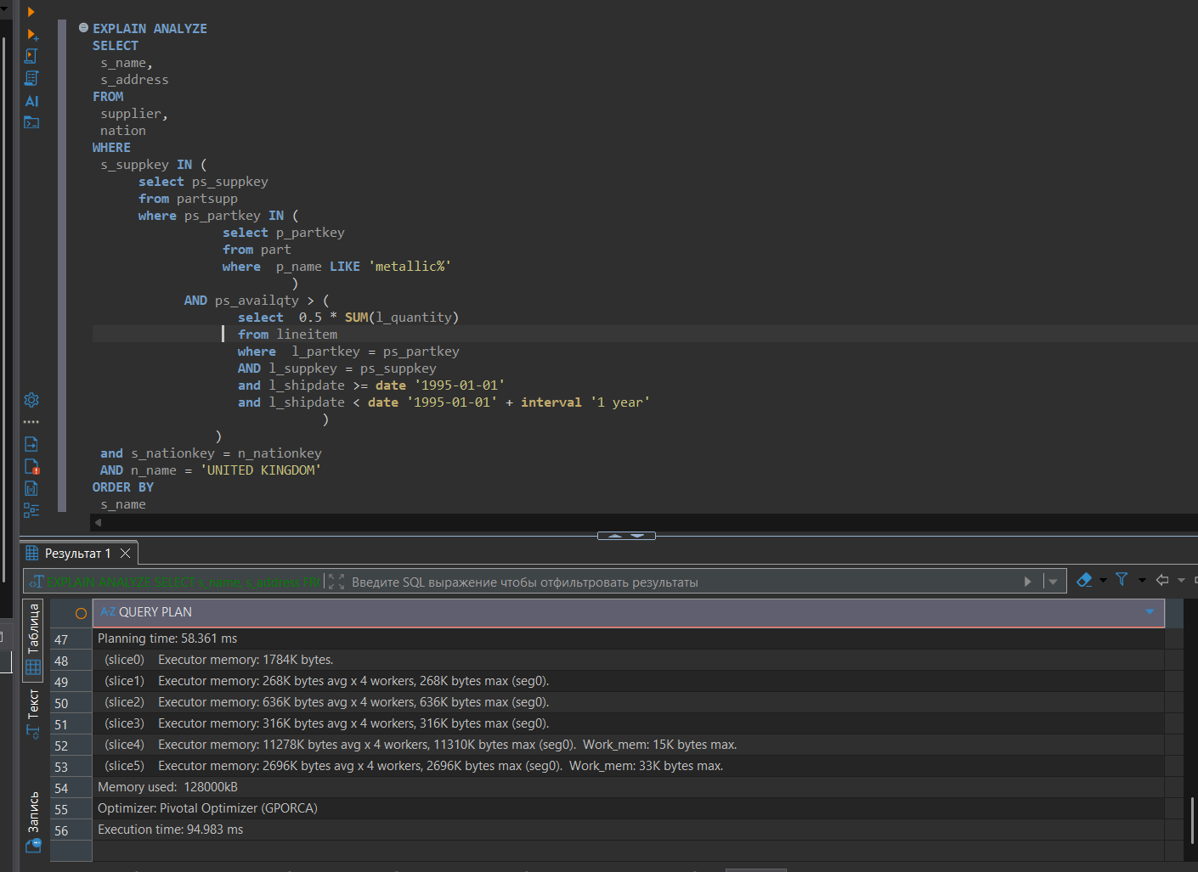

- Дополнительно пишем простой запрос с использованием самых больших таблиц и двумя фильтрами
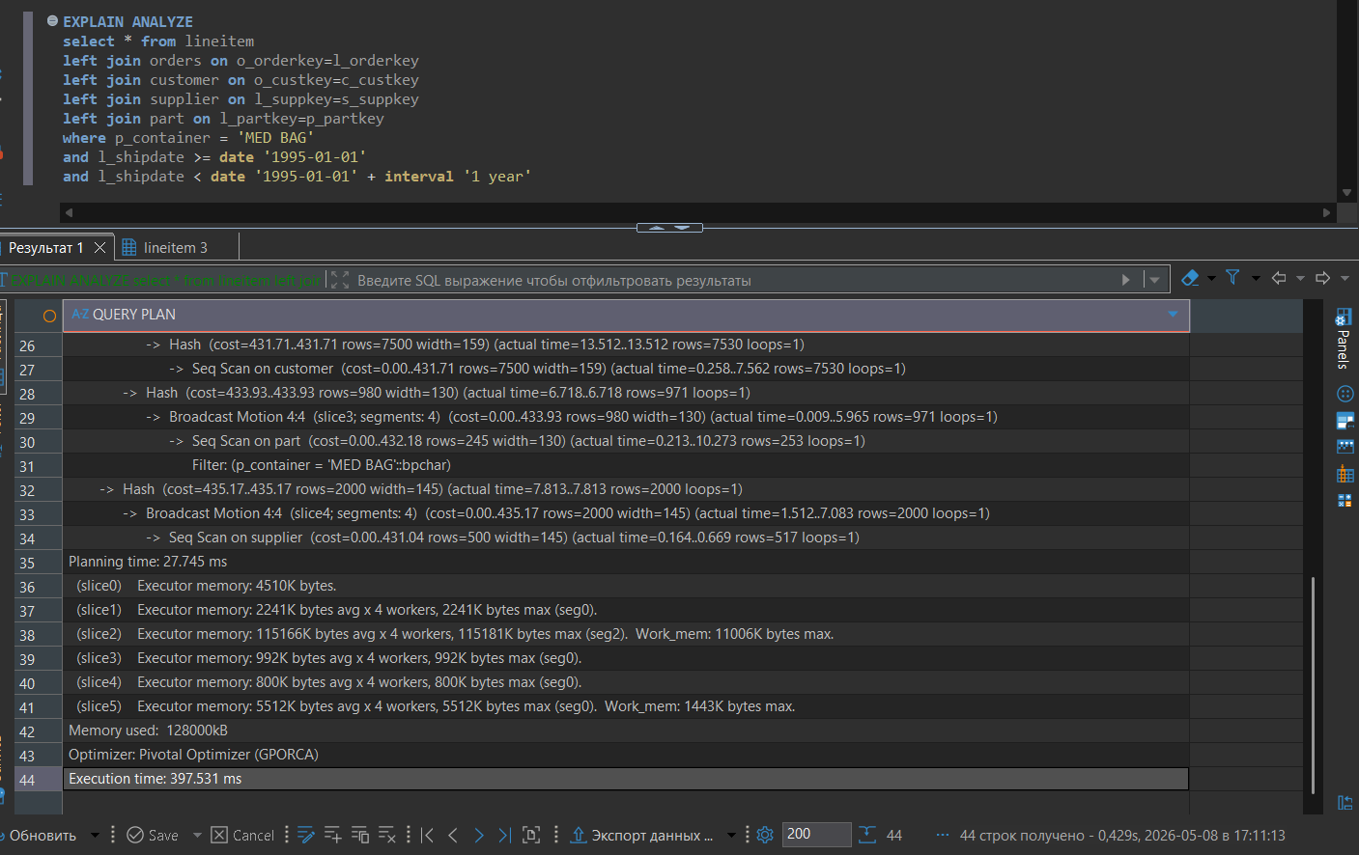

- При этом таблицы Lineitem и Part созданы без ПАРТИЦИОНИРОВАНИЯ

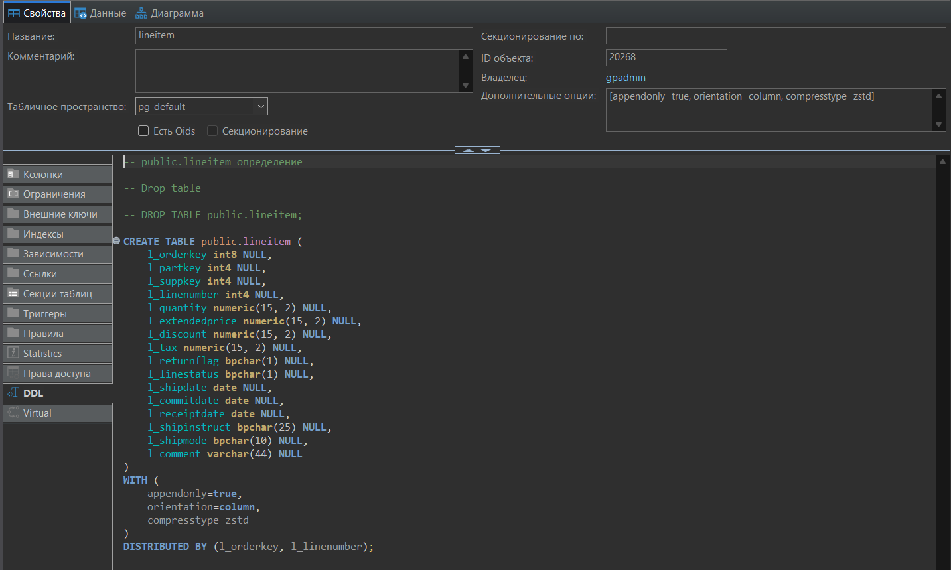
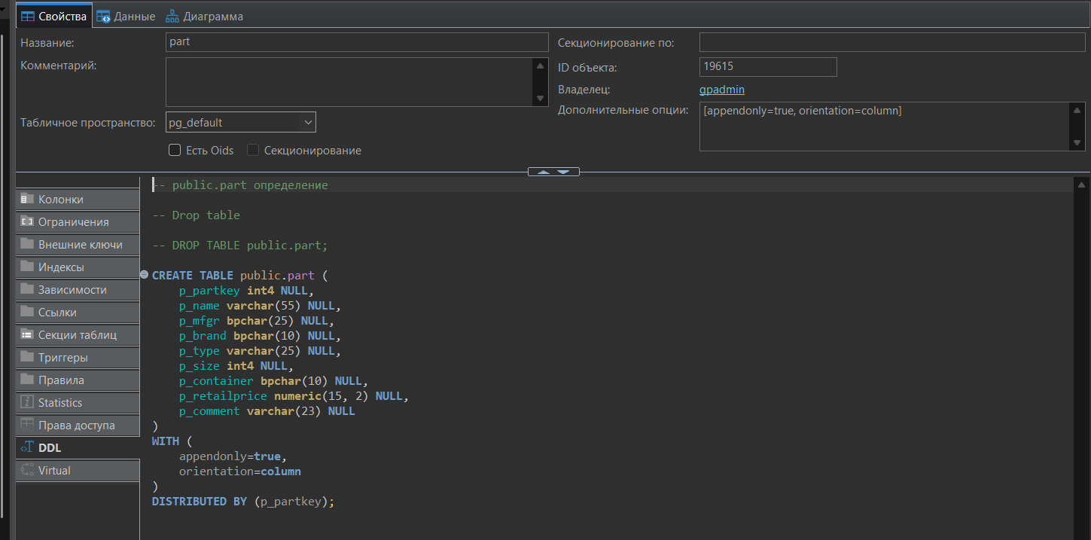

- Немного оптимизируем запрос из Интернета и смотрим на сколько уменьшилось время выполнения запрос
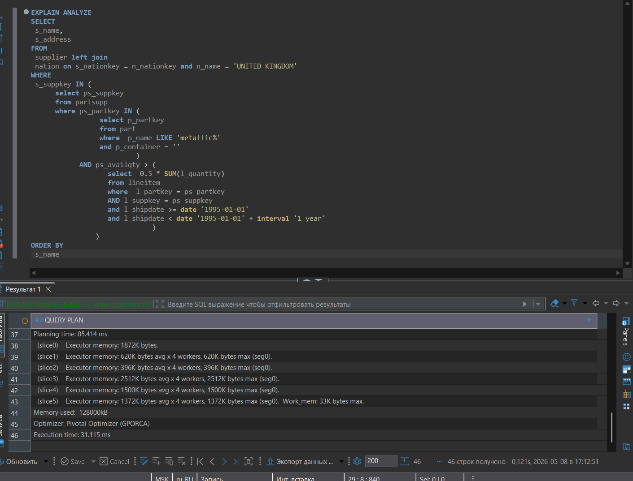

- Добавляем партиционирование в таблицы Lineitem и Part
CREATE TABLE lineitem_2 (
L_ORDERKEY BIGINT,
L_PARTKEY INT,
L_SUPPKEY INT,
L_LINENUMBER INTEGER,
L_QUANTITY DECIMAL(15, 2),
L_EXTENDEDPRICE DECIMAL(15, 2),
L_DISCOUNT DECIMAL(15, 2),
L_TAX DECIMAL(15, 2),
L_RETURNFLAG CHAR(1),
L_LINESTATUS CHAR(1),
L_SHIPDATE DATE,
L_COMMITDATE DATE,
L_RECEIPTDATE DATE,
L_SHIPINSTRUCT CHAR(25),
L_SHIPMODE CHAR(10),
L_COMMENT VARCHAR(44)
) WITH (
appendonly = true,
orientation = column,
compresstype = ZSTD
)
DISTRIBUTED BY (L_ORDERKEY, L_LINENUMBER)
PARTITION BY RANGE (L_SHIPDATE)
(start('1992-01-01') INCLUSIVE end ('1998-12-31') INCLUSIVE every (30), default partition others);

INSERT INTO lineitem_2 SELECT * FROM lineitem

drop table lineitem

ALTER TABLE lineitem_2 RENAME TO lineitem

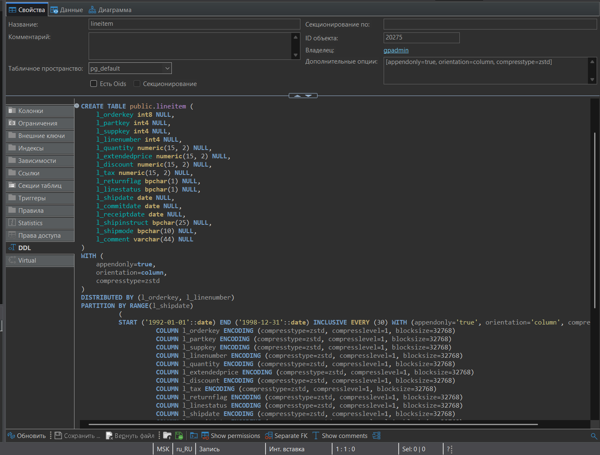
CREATE TABLE part_2 (
P_PARTKEY INT,
P_NAME VARCHAR(55),
P_MFGR CHAR(25),
P_BRAND CHAR(10),
P_TYPE VARCHAR(25),
P_SIZE INTEGER,
P_CONTAINER CHAR(10),
P_RETAILPRICE DECIMAL(15, 2),
P_COMMENT VARCHAR(23),
P_DOP VARCHAR(23)
) WITH (appendonly = true, orientation = column)
DISTRIBUTED BY (P_PARTKEY)
PARTITION BY LIST (P_CONTAINER)
( PARTITION BAG VALUES ('MED BAG','JUMBO BAG','LG BAG','JUMBO BAG','WRAP BAG'),
PARTITION JAR VALUES ('WRAP JAR','MED JAR','SM JAR','JUMBO JAR','LG JAR'),
PARTITION PKG VALUES ('SM PKG','LG PKG','MED PKG','JUMBO PKG','WRAP PKG'),
PARTITION BOX_c VALUES ('LG BOX','SM BOX','MED BOX','WRAP BOX','JUMBO BOX'),
PARTITION DRUM VALUES ('MED DRUM','LG DRUM','JUMBO DRUM','SM DRUM','WRAP DRUM'),
PARTITION CASE_c VALUES ('MED_CASE','WRAP CASE','JUMBO CASE','LG CASE','SM CASE'),
PARTITION PACK VALUES ('JUMBO PACK','LG PACK','SM PACK','MED PACK','WRAP PACK'),
PARTITION CAN VALUES ('SM CAN','MED CAN','LG CAN','JUMBO CAN','WRAP CAN'),
DEFAULT PARTITION other );

INSERT INTO part_2 SELECT * FROM part

drop table part

ALTER TABLE part_2 RENAME TO part

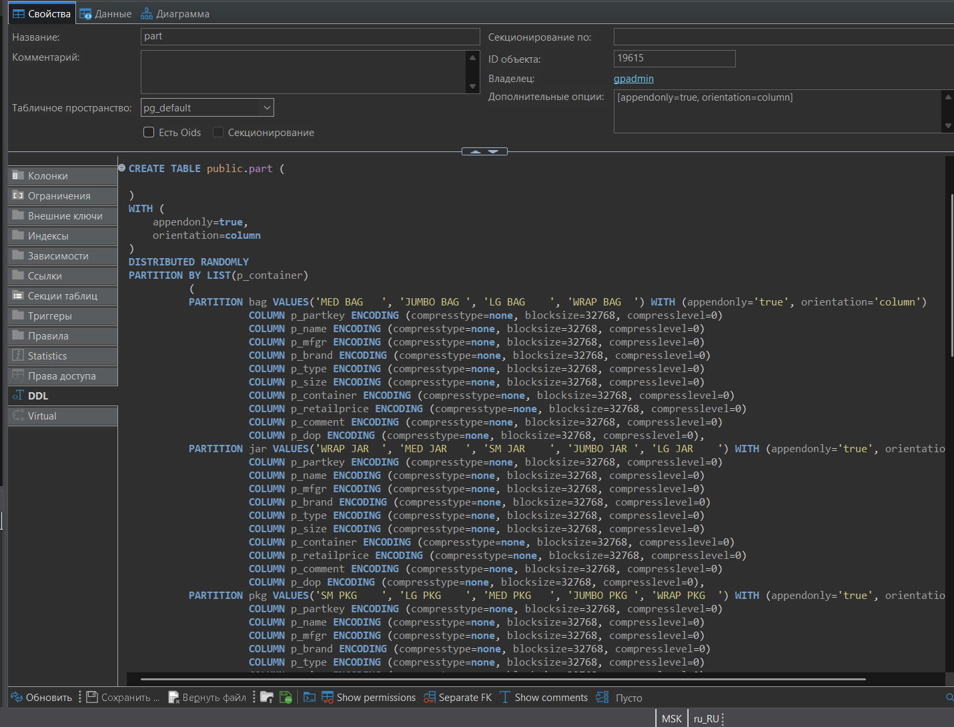

- Смотрим сколько времени будет выполнятся запрос c фильтрами на партиционированные поля
1 запрос из Интернета
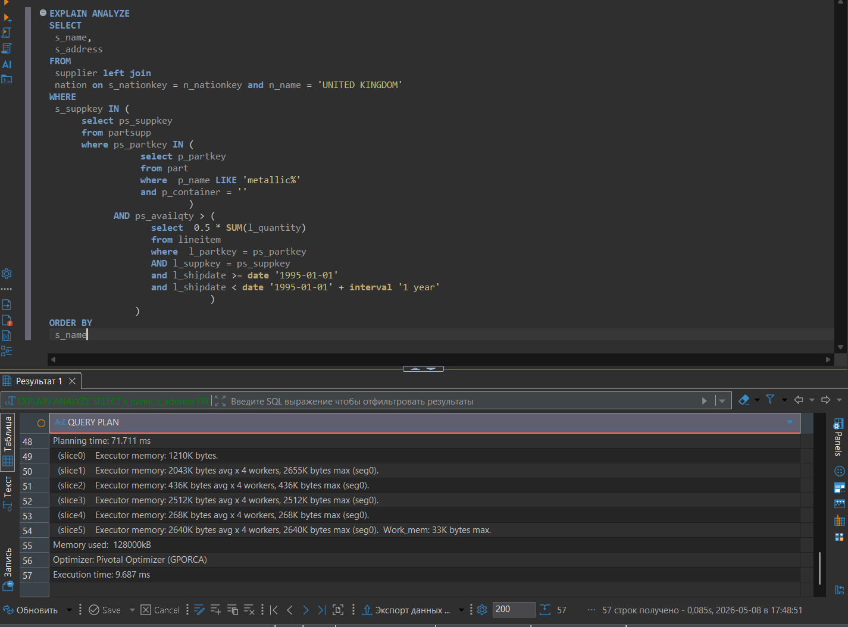
Время выполнения запроса уменьшилось в 3 раза
2 запрос с простыми джойнами
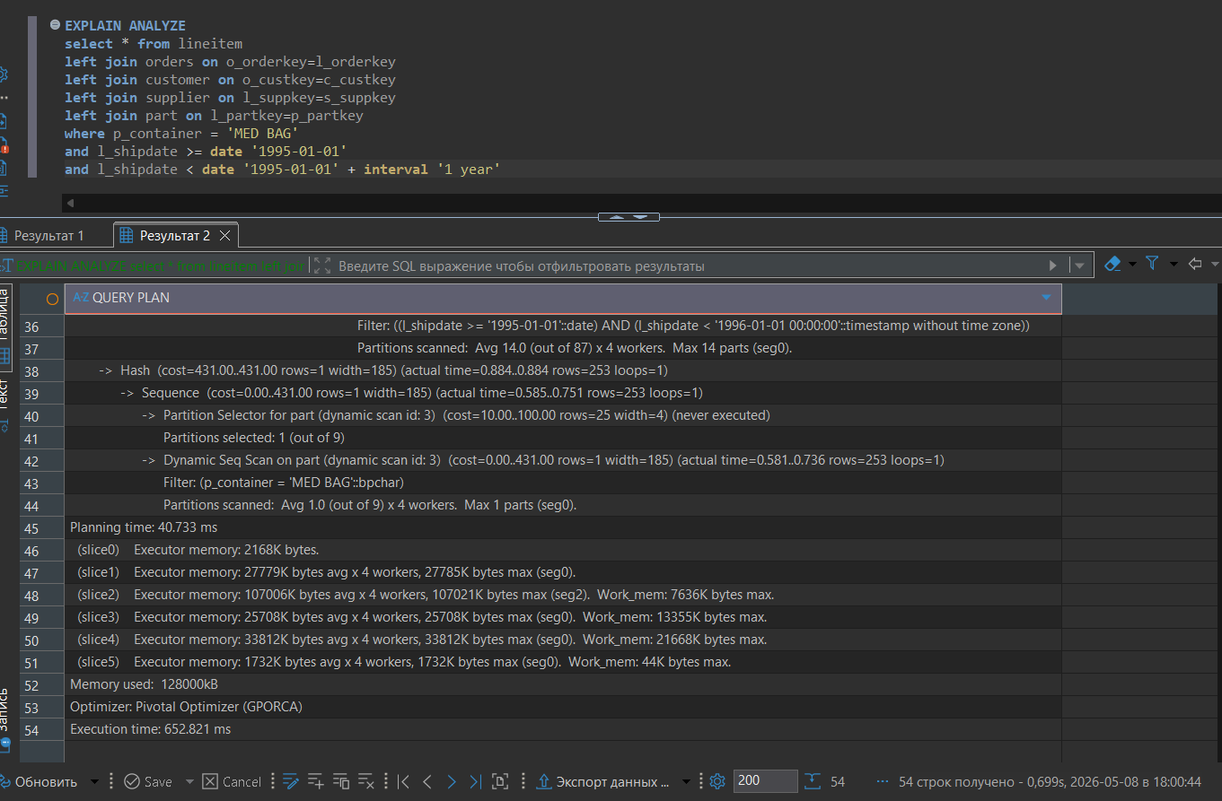
Время запроса увеличилось в 2 раза.
Сравнивала оба плана запроса, но ничего глобально разного не подчерпнула для себя
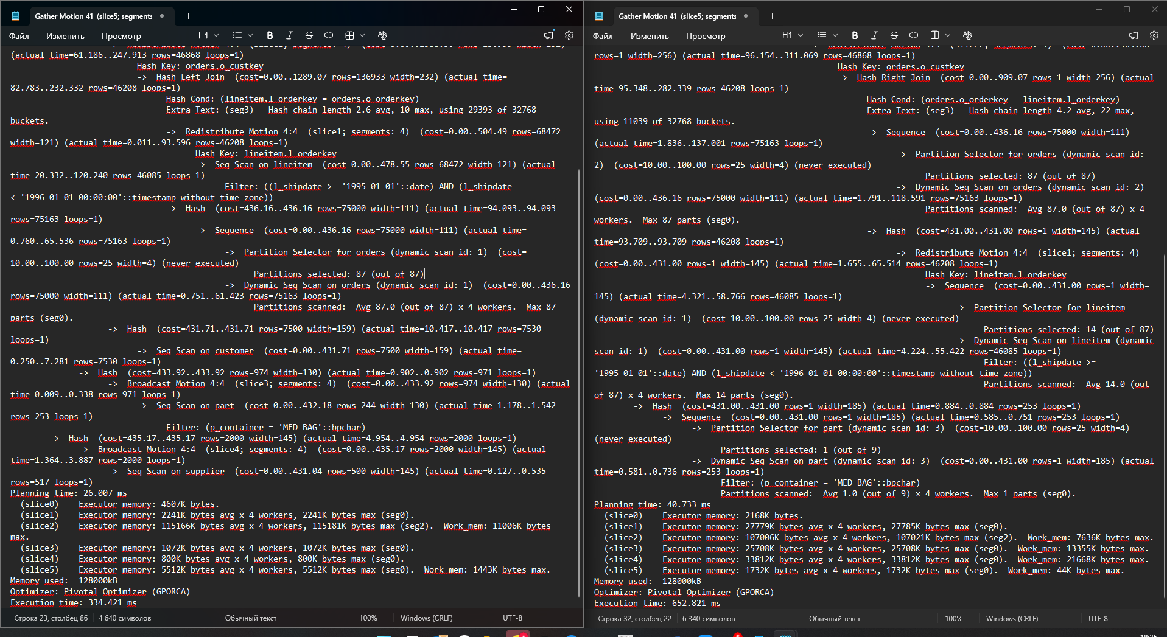
Количество записей в партиции несильно перекошены:
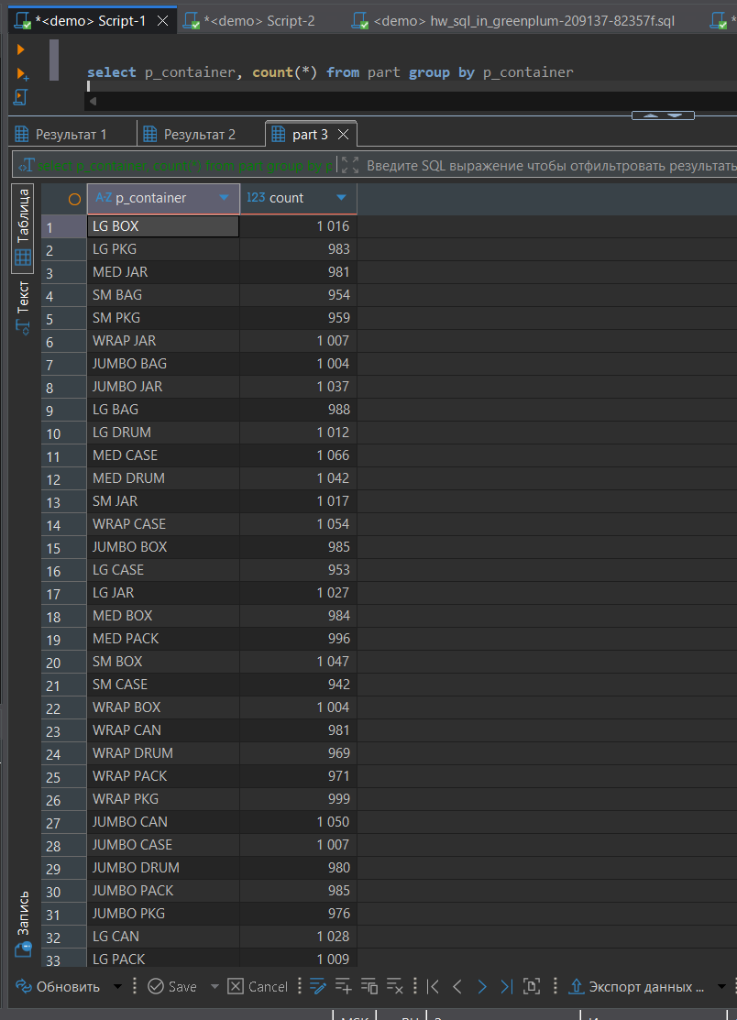

Планы запроса прилагаю
Без партиционирования
Gather Motion 4:1 (slice5; segments: 4) (cost=0.00..3417.40 rows=53694 width=666) (actual time=84.136..330.633 rows=4472 loops=1)
-> Hash Left Join (cost=0.00..3297.79 rows=13424 width=666) (actual time=76.813..322.991 rows=1162 loops=1)
Hash Cond: (lineitem.l_suppkey = supplier.s_suppkey)
Extra Text: (seg1) Hash chain length 1.0 avg, 2 max, using 1944 of 32768 buckets.
-> Hash Join (cost=0.00..2821.24 rows=6732 width=521) (actual time=72.385..316.754 rows=1162 loops=1)
Hash Cond: (lineitem.l_partkey = part.p_partkey)
Extra Text: (seg1) Hash chain length 1.0 avg, 2 max, using 963 of 32768 buckets.
-> Hash Left Join (cost=0.00..2261.33 rows=268856 width=391) (actual time=71.655..302.004 rows=46868 loops=1)
Hash Cond: (orders.o_custkey = customer.c_custkey)
Extra Text: (seg1) Hash chain length 1.1 avg, 4 max, using 6713 of 32768 buckets.
-> Redistribute Motion 4:4 (slice2; segments: 4) (cost=0.00..1388.50 rows=136933 width=232) (actual time=61.186..247.913 rows=46868 loops=1)
Hash Key: orders.o_custkey
-> Hash Left Join (cost=0.00..1289.07 rows=136933 width=232) (actual time=82.783..232.332 rows=46208 loops=1)
Hash Cond: (lineitem.l_orderkey = orders.o_orderkey)
Extra Text: (seg3) Hash chain length 2.6 avg, 10 max, using 29393 of 32768 buckets.
-> Redistribute Motion 4:4 (slice1; segments: 4) (cost=0.00..504.49 rows=68472 width=121) (actual time=0.011..93.596 rows=46208 loops=1)
Hash Key: lineitem.l_orderkey
-> Seq Scan on lineitem (cost=0.00..478.55 rows=68472 width=121) (actual time=20.332..120.240 rows=46085 loops=1)
Filter: ((l_shipdate >= '1995-01-01'::date) AND (l_shipdate < '1996-01-01 00:00:00'::timestamp without time zone))
-> Hash (cost=436.16..436.16 rows=75000 width=111) (actual time=94.093..94.093 rows=75163 loops=1)
-> Sequence (cost=0.00..436.16 rows=75000 width=111) (actual time=0.760..65.536 rows=75163 loops=1)
-> Partition Selector for orders (dynamic scan id: 1) (cost=10.00..100.00 rows=25 width=4) (never executed)
Partitions selected: 87 (out of 87)
-> Dynamic Seq Scan on orders (dynamic scan id: 1) (cost=0.00..436.16 rows=75000 width=111) (actual time=0.751..61.423 rows=75163 loops=1)
Partitions scanned: Avg 87.0 (out of 87) x 4 workers. Max 87 parts (seg0).
-> Hash (cost=431.71..431.71 rows=7500 width=159) (actual time=10.417..10.417 rows=7530 loops=1)
-> Seq Scan on customer (cost=0.00..431.71 rows=7500 width=159) (actual time=0.250..7.281 rows=7530 loops=1)
-> Hash (cost=433.92..433.92 rows=974 width=130) (actual time=0.902..0.902 rows=971 loops=1)
-> Broadcast Motion 4:4 (slice3; segments: 4) (cost=0.00..433.92 rows=974 width=130) (actual time=0.009..0.338 rows=971 loops=1)
-> Seq Scan on part (cost=0.00..432.18 rows=244 width=130) (actual time=1.178..1.542 rows=253 loops=1)
Filter: (p_container = 'MED BAG'::bpchar)
-> Hash (cost=435.17..435.17 rows=2000 width=145) (actual time=4.954..4.954 rows=2000 loops=1)
-> Broadcast Motion 4:4 (slice4; segments: 4) (cost=0.00..435.17 rows=2000 width=145) (actual time=1.364..3.887 rows=2000 loops=1)
-> Seq Scan on supplier (cost=0.00..431.04 rows=500 width=145) (actual time=0.127..0.535 rows=517 loops=1)
Planning time: 26.007 ms
(slice0) Executor memory: 4607K bytes.
(slice1) Executor memory: 2241K bytes avg x 4 workers, 2241K bytes max (seg0).
(slice2) Executor memory: 115166K bytes avg x 4 workers, 115181K bytes max (seg2). Work_mem: 11006K bytes max.
(slice3) Executor memory: 1072K bytes avg x 4 workers, 1072K bytes max (seg0).
(slice4) Executor memory: 800K bytes avg x 4 workers, 800K bytes max (seg0).
(slice5) Executor memory: 5512K bytes avg x 4 workers, 5512K bytes max (seg0). Work_mem: 1443K bytes max.
Memory used: 128000kB
Optimizer: Pivotal Optimizer (GPORCA)
Execution time: 334.421 ms

После партиционирования таблиц

Gather Motion 4:1 (slice5; segments: 4) (cost=0.00..2209.44 rows=1 width=745) (actual time=485.981..632.236 rows=4472 loops=1)
-> Hash Join (cost=0.00..2209.43 rows=1 width=745) (actual time=484.208..624.850 rows=1142 loops=1)
Hash Cond: (lineitem.l_partkey = part.p_partkey)
Extra Text: (seg0) Hash chain length 1.0 avg, 1 max, using 253 of 32768 buckets.
-> Redistribute Motion 4:4 (slice4; segments: 4) (cost=0.00..1778.43 rows=1 width=560) (actual time=483.207..613.908 rows=46277 loops=1)
Hash Key: lineitem.l_partkey
-> Hash Right Join (cost=0.00..1778.42 rows=1 width=560) (actual time=482.421..528.123 rows=47697 loops=1)
Hash Cond: (supplier.s_suppkey = lineitem.l_suppkey)
Extra Text: (seg0) Hash chain length 93.0 avg, 194 max, using 513 of 16384 buckets.
-> Seq Scan on supplier (cost=0.00..431.04 rows=500 width=145) (actual time=0.430..1.431 rows=517 loops=1)
-> Hash (cost=1347.08..1347.08 rows=1 width=415) (actual time=481.770..481.770 rows=47697 loops=1)
-> Redistribute Motion 4:4 (slice3; segments: 4) (cost=0.00..1347.08 rows=1 width=415) (actual time=359.643..446.707 rows=47697 loops=1)
Hash Key: lineitem.l_suppkey
-> Hash Right Join (cost=0.00..1347.08 rows=1 width=415) (actual time=359.761..397.636 rows=46868 loops=1)
Hash Cond: (customer.c_custkey = orders.o_custkey)
Extra Text: (seg1) Hash chain length 11.7 avg, 63 max, using 4005 of 16384 buckets.
-> Seq Scan on customer (cost=0.00..431.71 rows=7500 width=159) (actual time=0.636..8.498 rows=7530 loops=1)
-> Hash (cost=909.08..909.08 rows=1 width=256) (actual time=358.522..358.522 rows=46868 loops=1)
-> Redistribute Motion 4:4 (slice2; segments: 4) (cost=0.00..909.08 rows=1 width=256) (actual time=96.154..311.069 rows=46868 loops=1)
Hash Key: orders.o_custkey
-> Hash Right Join (cost=0.00..909.07 rows=1 width=256) (actual time=95.348..282.339 rows=46208 loops=1)
Hash Cond: (orders.o_orderkey = lineitem.l_orderkey)
Extra Text: (seg3) Hash chain length 4.2 avg, 22 max, using 11039 of 32768 buckets.
-> Sequence (cost=0.00..436.16 rows=75000 width=111) (actual time=1.836..137.001 rows=75163 loops=1)
-> Partition Selector for orders (dynamic scan id: 2) (cost=10.00..100.00 rows=25 width=4) (never executed)
Partitions selected: 87 (out of 87)
-> Dynamic Seq Scan on orders (dynamic scan id: 2) (cost=0.00..436.16 rows=75000 width=111) (actual time=1.791..118.591 rows=75163 loops=1)
Partitions scanned: Avg 87.0 (out of 87) x 4 workers. Max 87 parts (seg0).
-> Hash (cost=431.00..431.00 rows=1 width=145) (actual time=93.709..93.709 rows=46208 loops=1)
-> Redistribute Motion 4:4 (slice1; segments: 4) (cost=0.00..431.00 rows=1 width=145) (actual time=1.655..65.514 rows=46208 loops=1)
Hash Key: lineitem.l_orderkey
-> Sequence (cost=0.00..431.00 rows=1 width=145) (actual time=4.321..58.766 rows=46085 loops=1)
-> Partition Selector for lineitem (dynamic scan id: 1) (cost=10.00..100.00 rows=25 width=4) (never executed)
Partitions selected: 14 (out of 87)
-> Dynamic Seq Scan on lineitem (dynamic scan id: 1) (cost=0.00..431.00 rows=1 width=145) (actual time=4.224..55.422 rows=46085 loops=1)
Filter: ((l_shipdate >= '1995-01-01'::date) AND (l_shipdate < '1996-01-01 00:00:00'::timestamp without time zone))
Partitions scanned: Avg 14.0 (out of 87) x 4 workers. Max 14 parts (seg0).
-> Hash (cost=431.00..431.00 rows=1 width=185) (actual time=0.884..0.884 rows=253 loops=1)
-> Sequence (cost=0.00..431.00 rows=1 width=185) (actual time=0.585..0.751 rows=253 loops=1)
-> Partition Selector for part (dynamic scan id: 3) (cost=10.00..100.00 rows=25 width=4) (never executed)
Partitions selected: 1 (out of 9)
-> Dynamic Seq Scan on part (dynamic scan id: 3) (cost=0.00..431.00 rows=1 width=185) (actual time=0.581..0.736 rows=253 loops=1)
Filter: (p_container = 'MED BAG'::bpchar)
Partitions scanned: Avg 1.0 (out of 9) x 4 workers. Max 1 parts (seg0).
Planning time: 40.733 ms
(slice0) Executor memory: 2168K bytes.
(slice1) Executor memory: 27779K bytes avg x 4 workers, 27785K bytes max (seg0).
(slice2) Executor memory: 107006K bytes avg x 4 workers, 107021K bytes max (seg2). Work_mem: 7636K bytes max.
(slice3) Executor memory: 25708K bytes avg x 4 workers, 25708K bytes max (seg0). Work_mem: 13355K bytes max.
(slice4) Executor memory: 33812K bytes avg x 4 workers, 33812K bytes max (seg0). Work_mem: 21668K bytes max.
(slice5) Executor memory: 1732K bytes avg x 4 workers, 1732K bytes max (seg0). Work_mem: 44K bytes max.
Memory used: 128000kB
Optimizer: Pivotal Optimizer (GPORCA)
Execution time: 652.821 ms

